WEEK NUMBER: | 10
STUDENT NAME: | Anas Al Azad
STUDENT ID: | 105694136
Week 10 – Genetic algorithms with PyGAD (linear model + 8 Queen puzzle)
My checklist for this week – ticked = done, unticked = still to do. Everything is in the Lab 10 folder of my repo (Lab10_Genetic_Algorithms.ipynb + the two fixed tutor programs).
LAB 10 CHECKLIST (☒ = done, ☐ = still to do) |  | STATUS
☒ | Read the Week 10 sheet (PyGAD, fitting a linear model, 8 Queen puzzle) | Done
☒ | Fixed the tutor's two programs so they run with PyGAD 3 (table below) | Done
☒ | Linear model with the sheet's settings – output 43.9933 (target 44) | Done
☒ | Extra: tuned the GA – 8 settings × 20 seeds | Done
☒ | 8 Queens: ran the app's GA 30 times without the GUI + found and fixed the attack-count bug | Done
☒ | Extra: two better encodings for the queens (integer genes, permutation) | Done
☐ | Install PyGAD + Kivy on my laptop | To do
☐ | Run fitting_linear_model.py on my laptop | To do
☐ | Run the 8 Queen app (8_queen_puzzle.py) until it finds 0 attacks | To do
☐ | Screenshots added (yellow boxes below) | To do
Progress: 6/10 items done

WEEK # | 10
Dates covered: | 5–11 October 2026
Lab tasks | What I did | TIME SPENT | Learning & Problems
PyGAD basics  Sheet part 1 | - Installed PyGAD (version 3.8.1 – the sheet talks about 3.1.0).  - Learned the 4 steps: write a fitness function → choose the parameters → create pygad.GA → run(). Tried the 'fitness = sum of the solution' example on 3 made-up solutions (fitness 750, 949 and 263). | 0.5 h | Learning:  - A GA works on a population of answers: the fittest become parents, crossover mixes them, mutation adds small random changes, repeat each generation.  - The fitness function is the only part that's specific to the problem.  Problems:  - The sheet's code is for an older PyGAD – the fitness function now needs 3 inputs (ga_instance, solution, solution_idx).
Fitting a linear model  Sheet part 2, fitting_linear_model.py | - Found 6 weights so that 4w1 − 2w2 + 3.5w3 + 5w4 − 11w5 − 4.7w6 = 44, with the sheet's settings (50 generations, 8 solutions, steady-state selection, single-point crossover).  - Best weights [3.64, 1.65, 4.47, 0.01, −1.37, −0.43] → output 43.9933 (fitness 149). The error went from 1.78 to 0.0067 by generation 4, then didn't improve for the other 46 generations (Fig 10.1).  - Two other seeds gave completely different weights that also give ≈ 44. | 1 h | Learning:  - 1 equation and 6 unknowns means there are endless right answers – the GA just finds one.  - With only 8 solutions the population quickly becomes all the same, and then it gets stuck.  Problems:  - The tutor's file crashed twice on PyGAD 3: the fitness function needed 3 inputs, and plot_result() is now plot_fitness(). Fixed both (marked *my fix*).  - PyGAD warns that keep_elitism (default 1) overrides the sheet's keep_parents=1.
Tuning the GA  My experiment | - Ran 8 different settings with 20 seeds each and compared the median error |output − 44| (table + Fig 10.2).  - Best: 200 generations + 50 per population – median error 0.0003, all 20 runs within 0.01 (sheet settings: 0.0073, 14/20). Worst: mutating 50% of the genes – 0.0294, 6/20. | 1 h | Learning:  - A GA is random, so you have to compare settings over many runs, not one.  - More solutions and more generations help but cost time (9.4 s vs 0.7 s for 20 runs). Too much mutation just wrecks good answers.  - Steady-state selection (the sheet's choice) beat tournament and roulette wheel here.  Problems:  - None really for this one.
8 Queen puzzle  Sheet part 3, 8_queen_puzzle.py | - Each answer = 8 numbers, the column of the queen in each row. Fitness = 1 / attacks, or 1.1 for 0 attacks.  - The app crashed as soon as I pressed Initial Population (delay_after_gen was removed from PyGAD), and Start GA froze the window. Fixed both.  - Found a bug in the attack counting: all 8 queens on one diagonal (28 attacking pairs) came out as 126. Fixed it.  - Ran the app's GA 30 times without the GUI: it found a 0-attack board 20/30 times (median 55 generations). With the original counting it was only 14/30 (Fig 10.3, 10.4). | 1.5 h | Learning:  - The GA can still solve it with a wrong fitness (0 attacks is still 0), but a wrong count ranks the other boards badly, so it finds the answer less often.  - It doesn't always find the solution in 100 generations – the sheet says this too.  Problems:  - Three crashes/bugs in the tutor's app (details in the table below).  - In the app the genes become decimals like 3.7 after crossover and mutation – the board just rounds them down.
Better encodings  My experiment | - Integer genes (gene_space=range(8)): 13/30 – no better.  - Permutation (every column used exactly once, swap mutation): 30/30, median 1 generation, 0.1 s per run. | 0.5 h | Learning:  - How you write the answer down matters more than the GA settings: with a permutation, column attacks are impossible, so only the diagonals are left to fix.  - Part of it is luck: 8 of the 30 random starting populations already contained a solution (0 of 30 for the app's style). The rest still got solved in a few generations.  Problems:  - None really for this one.
TOTAL TIME THIS WEEK |  | 4.5 h | + ~30 min laptop runs & screenshots

Screenshots:
Figures 10.1–10.4 come straight out of my notebook. The yellow boxes are screenshots I still need to take on my laptop. Set-up first: in the terminal, in the LabChallenge folder, run source .venv/bin/activate then pip install pygad kivy (Windows: .venv\Scripts\activate). Then cd "Lab 10" and do the steps below.
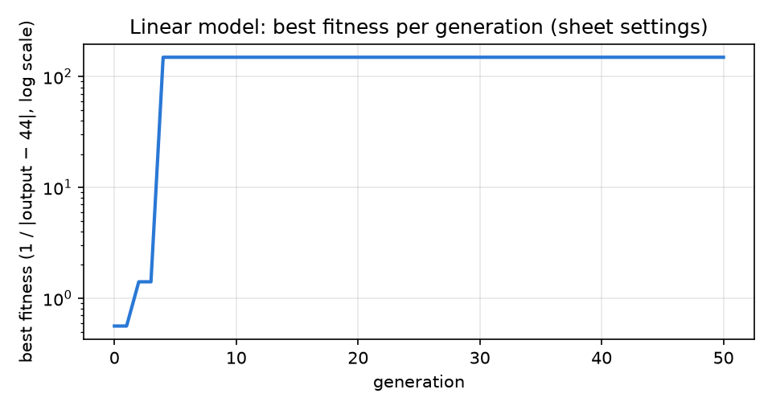
Figure 10.1 – linear model – best fitness each generation (sheet settings, log scale)
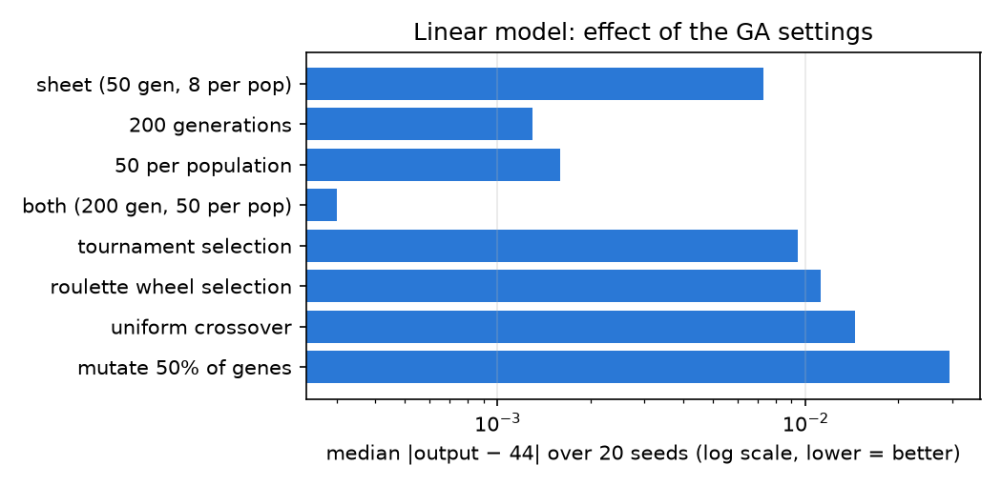
Figure 10.2 – linear model – median error over 20 runs for each setting (lower = better)
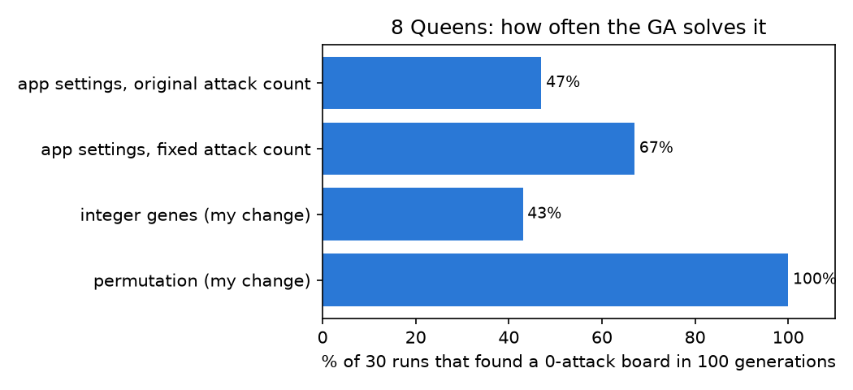
Figure 10.3 – 8 Queens – how often each version found a 0-attack board in 30 runs
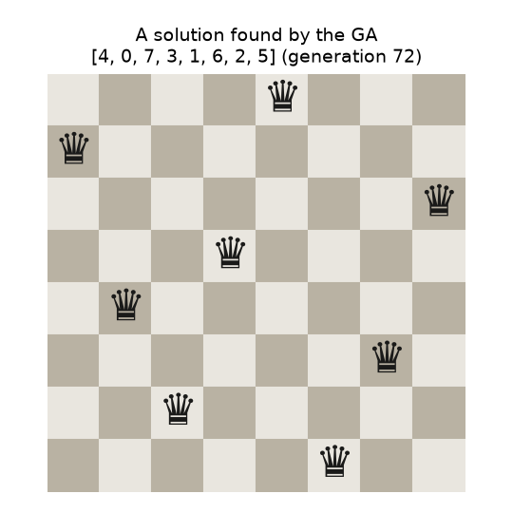
Figure 10.4 – one of the solutions the GA found: [4, 0, 7, 3, 1, 6, 2, 5]
[SCREENSHOT 10.1] Terminal – PyGAD and Kivy installed
What to capture: the end of pip install pygad kivy ('Successfully installed …' or 'Requirement already satisfied'), then run python -c "import pygad; print(pygad.__version__)" and include the version line.
Save as Lab 10/screenshots/10.1_install.png then run python _tools/insert_screenshots.py (or just paste the image here and delete this box).
Screenshot 10.1 – Terminal – PyGAD and Kivy installed
[SCREENSHOT 10.2] Linear model – output + fitness plot
What to capture: run python fitting_linear_model.py. A plot window opens – take one shot of the plot, close it, then a second shot of the terminal lines 'Parameters of the best solution … Predicted output … Best fitness value reached after … generations'. Name them 10.2a_… and 10.2b_….
Save as Lab 10/screenshots/10.2_linear_model.png then run python _tools/insert_screenshots.py (or just paste the image here and delete this box).
Screenshot 10.2 – Linear model – output + fitness plot
[SCREENSHOT 10.3] 8 Queens app – random starting board
What to capture: run python 8_queen_puzzle.py, click Initial Population, then Show Best Solution – screenshot the whole window (board with green 'Queen' squares and the 'Attacks = …' label).
Save as Lab 10/screenshots/10.3_queens_start.png then run python _tools/insert_screenshots.py (or just paste the image here and delete this box).
Screenshot 10.3 – 8 Queens app – random starting board
[SCREENSHOT 10.4] 8 Queens app – solved
What to capture: click Start GA and wait until the label says 'Attacks = 0' (if it stops above 0 after 100 generations, click Initial Population and Start GA again). Screenshot the window with the solved board, plus the terminal with the last 'Generation = … / Fitness = 1.1' lines (10.4a_… + 10.4b_…).
Save as Lab 10/screenshots/10.4_queens_solved.png then run python _tools/insert_screenshots.py (or just paste the image here and delete this box).
Screenshot 10.4 – 8 Queens app – solved
[SCREENSHOT 10.5] Notebook – tuning table
What to capture: open Lab10_Genetic_Algorithms.ipynb in Jupyter (no need to re-run) and screenshot the tuning table under 'My experiments – tuning the GA'.
Save as Lab 10/screenshots/10.5_tuning_table.png then run python _tools/insert_screenshots.py (or just paste the image here and delete this box).
Screenshot 10.5 – Notebook – tuning table
[SCREENSHOT 10.6] Notebook – 8 Queens results
What to capture: in the same notebook, the 'original code says 126 attacks, fixed code says 28' lines and the table with solved 14/30, 20/30, 13/30, 30/30.
Save as Lab 10/screenshots/10.6_queens_table.png then run python _tools/insert_screenshots.py (or just paste the image here and delete this box).
Screenshot 10.6 – Notebook – 8 Queens results
[SCREENSHOT 10.7] My fixes in the code
What to capture: 8_queen_puzzle.py open in VS Code (or TextEdit) showing a couple of the lines marked (my fix), e.g. pygadThread.start() and stop_criteria="reach_1.1".
Save as Lab 10/screenshots/10.7_my_fixes.png then run python _tools/insert_screenshots.py (or just paste the image here and delete this box).
Screenshot 10.7 – My fixes in the code
Then: save the screenshots in Lab 10/screenshots/ with those names, and from the LabChallenge folder run python _tools/insert_screenshots.py 10, python _tools/tick_checklist.py 10 7 8 9 10 and python _tools/make_handin.py 10.
What I fixed in the tutor's programs (PyGAD 3)
All changes are marked (my fix) in the code.
File | Problem | My fix
fitting_linear_model.py | fitness_func(solution, solution_idx) → *ValueError: fitness_func must accept 3 positional arguments* (PyGAD 3 passes the GA as well). | fitness_func(ga_instance, solution, solution_idx)
fitting_linear_model.py | plot_result() doesn't exist any more → *AttributeError*. | plot_fitness()
8_queen_puzzle.py | Pressing Initial Population crashed: *unexpected keyword argument 'delay_after_gen'* (removed in PyGAD 3). | Removed it; a 0.2 s pause in the generation callback instead, and stop_criteria="reach_1.1" so it stops when the puzzle is solved.
8_queen_puzzle.py | Start GA called thread.run(), which runs the GA on the window's own thread, so the board froze until it finished. | thread.start(), and the board is redrawn with Clock.schedule_once (only the window's thread may draw).
8_queen_puzzle.py | attacks_diagonal never reset its running total for each queen, so attacks were over-counted – 126 instead of 28 when all queens are on one diagonal. | Reset total = 0 for each queen – now it counts each attacking pair once.
Results – tuning the linear model (20 seeds per setting)
Setting | Median error | Worst error | Within 0.01
Sheet settings (50 generations, 8 per population) | 0.0073 | 0.0331 | 14/20
200 generations | 0.0013 | 0.0133 | 19/20
50 per population | 0.0016 | 0.0079 | 20/20
200 generations + 50 per population | 0.0003 | 0.0012 | 20/20
Tournament selection | 0.0094 | 0.0482 | 10/20
Roulette wheel selection | 0.0112 | 0.0601 | 8/20
Uniform crossover | 0.0145 | 0.0348 | 8/20
Mutate 50% of genes | 0.0294 | 0.0994 | 6/20
Results – 8 Queens (30 runs each, max 100 generations)
Version | Found 0 attacks | Median generations | Time per run
App settings, original attack count | 14/30 (47%) | 60 | 1.3 s
App settings, fixed attack count | 20/30 (67%) | 55 | 1.2 s
Integer genes (my change) | 13/30 (43%) | 71 | 1.3 s
Permutation – each column once (my change) | 30/30 (100%) | 1 | 0.1 s
Questions I asked myself
1. How does a genetic algorithm work?
It keeps a population of possible answers. Each generation it scores them with the fitness function, picks the best as parents, mixes pairs of parents (crossover) to make children, randomly changes a few genes (mutation), and repeats. Good answers spread, bad ones die out – like evolution.
2. Why is the fitness 1 / |output − 44| and not just the error?
PyGAD always tries to make fitness bigger. The error should get smaller, so flipping it (1 / error) turns 'small error' into 'big fitness'. For the queens it's the same idea with the number of attacks, and 1.1 when there are none (because 1/0 would break).
3. Why doesn't the GA always find the best answer?
It's random and only tries a small part of all possible answers. It can get stuck when the population becomes too similar (my linear run stopped improving after generation 4), and with a bad starting population or too few generations it runs out of time – the app settings solved the queens only 20 times out of 30.
4. What made the biggest difference?
For the linear model: a bigger population and more generations (median error 0.0073 → 0.0003). For the queens: choosing a better way to write the answer down. Making each answer a permutation removes all column attacks, so the GA only has to sort out the diagonals – it solved all 30 runs.
5. How is this different from the search and learning we did before?
Q-learning (Week 9) learns from rewards step by step, and gradient descent (Week 5) follows the slope of the error. A GA needs neither – just a way to score a whole answer – so it works even when there's no slope to follow, like placing queens on a board.

